Step 1: Open the Justification Builder
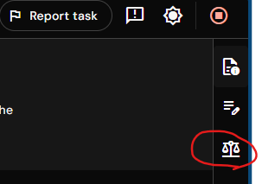
Click on the Justification Builder icon located on the right side of the screen.
This will open the justification panel.

Step 2: Add a new claim
Click on Add new claim. A new claim card will appear with the following fields:
- Claim
- Accuracy
- Classification
- Justification
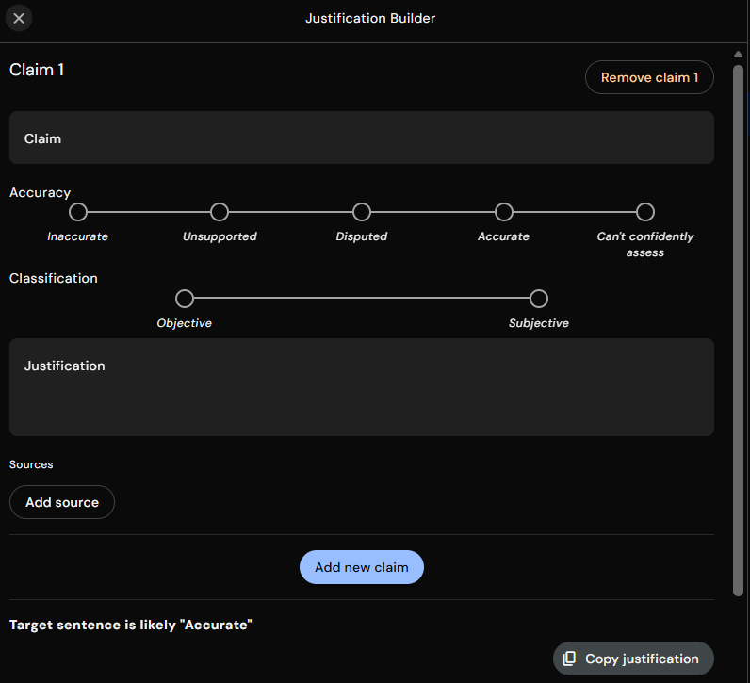
- Sources

Step 3: Enter the claim
In the Claim text box, type the statement you want to evaluate.
Example claim:
The closest Earth gets to the Sun is about 147 million kilometers.

Step 4: Mark the accuracy of the claim
Under Accuracy, select the option that best applies to the claim.
For this example:
- Select Accurate, because Earth reaches its closest point to the Sun, known as perihelion, at approximately 147 million kilometers.

Step 5: Classify the claim
Under Classification, choose whether the claim is Objective or Subjective.
For this example:
- Select Objective, since the distance between Earth and the Sun is a measurable scientific fact and does not depend on opinion or personal interpretation.

Step 6: Write the justification
In the Justification section, explain why the claim is accurate or inaccurate.
Example justification:
This claim is objectively verifiable and refers to a measurable astronomical fact. Earth follows an elliptical orbit around the Sun, and its closest point in that orbit is called perihelion. Scientific measurements consistently show that Earth reaches perihelion at a distance of approximately 147 million kilometers from the Sun. This value is widely documented by authoritative space agencies and scientific references, confirming the accuracy of the claim.

Step 7: Add sources
Under Sources, click Add source and include reliable references that support your justification.
Example sources (with links):
- APOD: 2025 January 4 - Welcome to Perihelion
- Earth at perihelion 2026: All you need to know - Space & Telescope

Step 8: Add additional claims if needed
Click Add new claim to evaluate the next statement, and repeat the same steps for each claim.

Step 9: Copy the justification
Once all claims are completed, click Copy justification.
Paste the copied content directly into the workspace or submission area.

